News Flash
Virtual Dressage Jan-Oct, discounted entry if paying for all by Jan 31st.
Please see our events page on the website for up-to-date events
Actual Dressage Comps Apr, May, June, Sept and Oct 2024
Training Demos with Tammy Weal Jan 2024
RDA Training sessions so far Mar, May, June, July, Sept and Oct
Mar 24th Training of the young to Grand Prix Dressage Horse Demo

WINTER 2023 NEWSLETTER

Dear Members,

Welcome to our WRC Winter Newsletter.
Firstly, thank you to everyone who managed to get to our AGM on November 15th at the RDA, we all had a fabulous time.
Congratulations to all our award winners and their four-legged friends, keep the pictures coming in.
We would like to thank our long-standing Committee members who have stepped down this year, for all the amazing work they have done on behalf of the club over the past years, Hazel, Ali, Catherine and Sarah. We thank you all and we look forward to seeing you all again soon.

Your new Committee and roles for 2024 are as follows:

- Lorna Warren – Chair & Website
- Andrew Lovell – Treasurer
- Rose Clarke – Secretary
- Sam Painter – Area 17
- Emma Palmer – Pleasure Riding, Newsletter
- Jody Stoker – Dressage Coordinator, Newsletter & social media

Memberships are now to be made directly to the BRC through the Sport:80 platform. Andrew has set up the WRC page, so members are now able to re-join.
We were told that all members would receive an invite to the Sport:80 platform, this would allow you to set up a password and edit your personal information in your BRC account and re-join WRC for 2024.

We have been made aware that some of you did not receive this invite from Sport:80, so if you follow the link below you will be able to set a password and access the platform to re-join WRC for 2024.

https://auth.sport80.com/password_set/c42050f1-6f42-47d6-a1a3-62ddc619af63

Below are some useful guides constructed by the BRC for membership issues:

How to update your personal details
https://britishridingclubs.sport80.com/uploads/how_to_update_your_personal_details-2023-11-24.pdf
Registering an existing BRC member
https://britishridingclubs.sport80.com/uploads/registering_an_existing_brc_member-2023-11-23.pdf
Adding another member to your account
https://britishridingclubs.sport80.com/uploads/adding_another_member_to_your_account-2023-11-23.pdf
If you have setup your account with a password and wish to access your account at any time then follow this link to log in to your BRC account https://britishridingclubs.sport80.com/.

If you are having any issues accessing the platform then please either email Andrew wrctreasurer2024@outlook.com or email the BRC brcmembership@bhs.org.uk

As always the year seems to of flown by and we are heading towards Christmas already. We have had a full year of training including clear round jumping, summer flatwork camp and a position clinic. We held our virtual and actual dressage competitions and Ride Coach Ride events plus social events and demos. Pleasure riding continued with many rosettes earned despite our challenging weather and terrain this year with all the recent rain and mud and prior to that the heatwaves and hard ground. Thinking of hot days a highlight in our Wessex Riding Club calendar must be running the Area Dressage to Music qualifier in June . We thank all of you who came and supported our events and thank you to all our judges and coaches and we are incredibly grateful to all of you especially to our volunteer helpers this year - some getting properly soaked in the rain! and many helping on numerous occasions.

Area 17 Events
A massive thank you goes out to Sam for doing an amazing job organising these Area events for our club members. It’s been great to see so many of you out competing for our club this year, and we have seen an encouraging number of entries, so don’t be shy in 2024!!!

Well done to everyone that took part in any Area events this year, you all did a brilliant job and should be proud of yourselves, as the club certainly are.

Here are the end of year notes from Sam:
2023 Qualifiers
WRC members attended 6 qualifiers during the year. 17 people took part across the 6 events.
Individual Placings:
1st x3
2nd x2
3rd x2
5th x3
6th x1
Team Placings:
2nd x1

DTM ran by WRC in June, was a great success.

2 members qualified for BRC National Champs.

Andrew attended BRC National Champs and placed 6th! Well done, Andrew and Ellie.

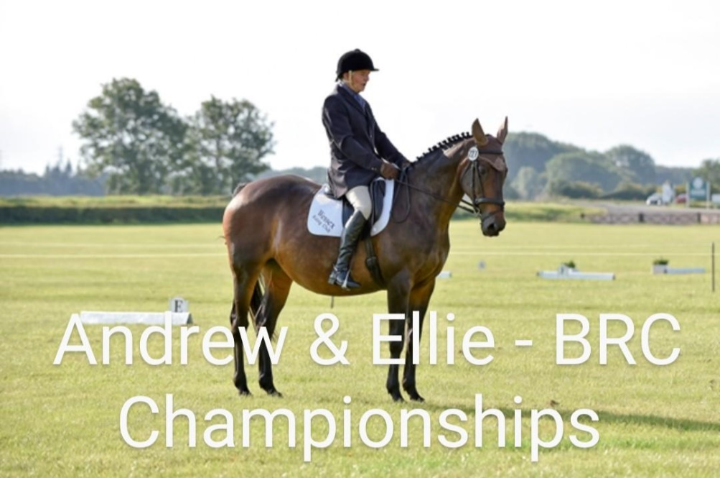

2024 Qualifiers

DTM qualifiers have already taken place for 2024 champs. Placings 1st, 2nd & 4th.
Another WRC member off to champs! Well done Emma and Cello.

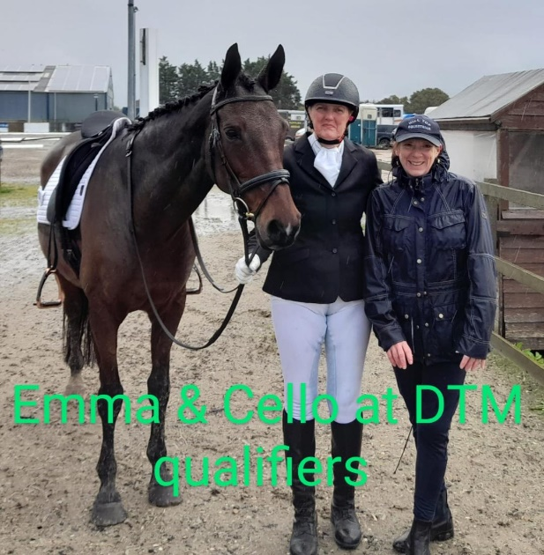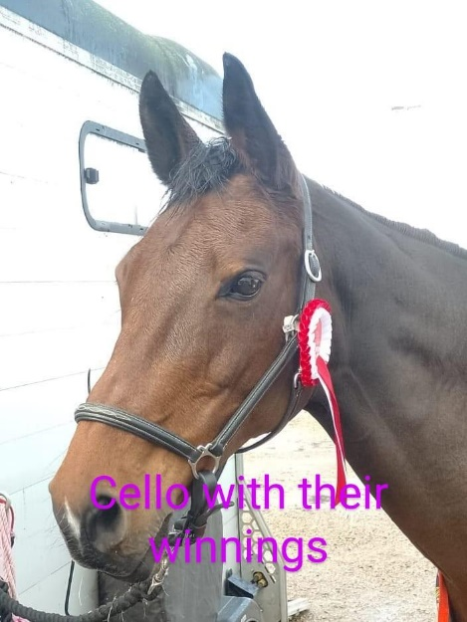

New Format Area 17 Championship
Since a lot of people choose not to go to champs, due to how far away they are the Area has decided to trial running its own championship over a weekend.
They will still run qualifying classes for the BRC champs if you are likely to want to travel to them.
The weekend will incorporate Dressage and Showjumping classes.
The details are still being ironed out and more information will be provided when we have it.
Make sure you save the date....
20th-21st July 2024

Nick Fincham
Nick has been a very long serving member of Area 17 as an Area Representative and also Treasurer. He has been involved since before 1986!
Nick is stepping down and the Area will be getting him a gift as a thank you for everything he has done.
Each Club agreed to contribute £50 (or whatever they could afford) towards the gift.
£50 has been paid by WRC.

Andrew has kindly written a blog about his experience at the BRC National Championships which is attached.

Please email Sam if you are interested in representing WRC at any of these events.
Sampainter07@gmail.com

Website
Lorna is now taking on the joy of reformatting and maintaining the WRC website making, with the aim to keep it updated and user friendly for all users.

Training, Events, Talk and Chats
Training has been well attended at the RDA and we thank them very much for these superb facilities and thanks go out to Di, Bim and Jo for opening and closing this wonderful venue for us.
Please respect the following rules set by the RDA which must be adhered to:
- No Smoking on site
- No Dogs permitted on site.
Thank you to our wonderful Horse and Rider combinations who have come along and enjoyed Sunday morning flat, poles or Jump sessions with superb tuition from a vast array of talented Instructors during 2023:
Jan: Amanda Barton & Stephen Way
Feb: Julia Cory & Stephen Way
Mar: Heather Lewis & Sarah Mitchell-Sheppard
Apr: Anna Jesty & Roland Bellido
May: Zoe Lunn & Trudi Wade
July: Nikki Green & Zoe Lunn
August: Julia Cory
November: Trudi Wade & Stephen Way
December: Nikki Green & Sarah Mitchell-Sheppard
We thank all our instructors who we feel very privileged to have been taught by during our Pick ‘n’ Mix sessions and we thank them for their continued support.
SOME HORSE/RIDERS FROM DECEMBERS PICK N MIX
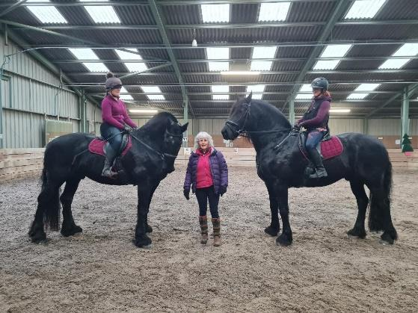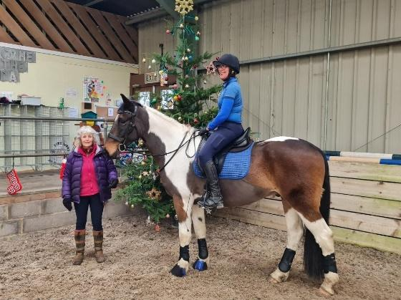

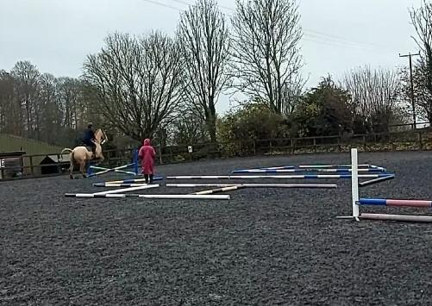
We have also enjoyed the following Horse and Social events:
- Guided Tour at Endell Equine Hospital
- Pub Quiz
- All Things Dressage Demo evening with Marcia Cundy
- Test Riding evening with Marcia Cundy
- Monday morning Training session at SMS Equestrian throughout the year with Sarah Mitchell- Sheppard
- Horselates Clinic with Anna Noble
- Improve your Dressage Scores ridden Demo/Talk with Sophie Gregory
- Straightness Day Camp at Hilltop Equestrian with Tammy Weal
- Cross Country Clinic at Dene Farm with Zoe Lunn
Please look at our events calendar on the website for all future events as we run regular Pick n Mix Training sessions throughout the year with different instructors, and changes are made as and when they happen.
Dressage
We will continue our monthly Virtual Dressage competitions (Jan-Oct) and Actual Dressage competitions held on Sunday mornings at Wilton RDA throughout 2024. Both events allow members that score over 60% to be awarded points following the BD points system for each competition they enter. At the end of the season points will be tallied up ready for the AGM where prizes will be awarded for placings 1-6 for each event (Virtual and Actual Dressage) Only WRC members qualify for these.

We thank all our lovely judges for their 2023 involvement:
Virtual Competitions
Mar: Marcia Cundy
Apr: Sarah Jane Prew
May: Eve Blachford
Jun: Sophie Gregory
Jul: Anna Jesty
Aug: Sarah Mitchell-Sheppard
Sept: Marcia Cundy
Oct: Sarah-Jane Prew

Actual Competitions
Mar: Sarah Jane Prew
Apr: Heather Lewis
May: Eve Blachford (RCR)
June: Sophie Gregory
July: Julie Jerome
Aug: Eve Blachford (RCR)
Sept: Donna Boyd
Oct: Marcia Cundy

Thank you so much to Ali for all her hard work with organising/ running our Dressage events throughout the year and to everyone who has helped her along the way in a variety of capacities. I hope that I can continue to run these events effectively, as I have some big shoes to fill. (Jody)

I have attached the end of year point’s spreadsheets for both the Virtual and the Actual events if anyone is interested in seeing how they are compiled and exactly what points they achieved this year.

Moving forward into 2024 all Dressage events whether Actual or Virtual will require an entry form being completed and sent to Jody dressagewrc@yahoo.com these forms will be available on the Website once all documents and schedules are compiled.

We are always looking for help to be offered at any event, so if you are ever available to help then please email any one of us.

All Dressage entry costs are remaining the same for 2024.

BD have announced that the Test Committee has completed a full review of all BD national tests. Their brief was to provide clearer progression through the levels, by streamlining, simplifying, and enhancing the BD test structure, to better support the training and development of riders.
This has resulted in the introduction of new tests.
We will be using the new tests in 2025, so no need to worry about learning new tests for 2024.
Chris, our lovely caller who generously gives up her time to call tests for anyone at our Dressage and Area events has raised £160 this year for Brooke, who are an international Charity that protects and improves the lives of Horses, Donkeys and Mules around the world. They thanked Chris for the ‘incredible donation’ so let's keep the donations coming for every test Chris calls for us (There will always be a donation box out for our actual Dressage events). To find out more about the incredible charity please use this link https://www.thebrooke.org/about-us
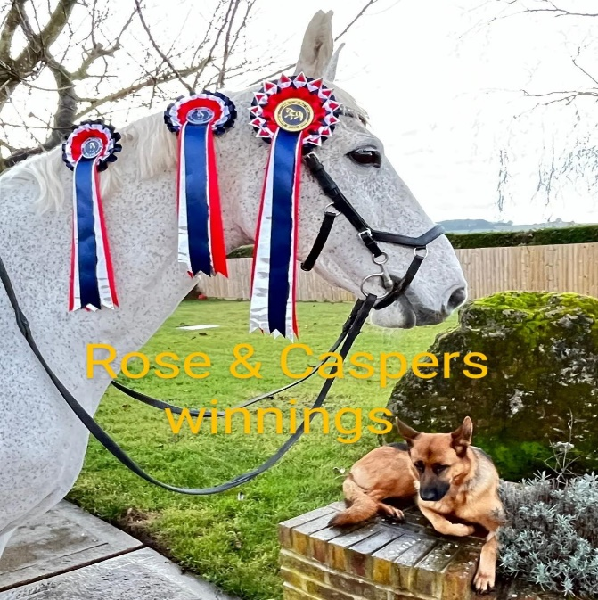
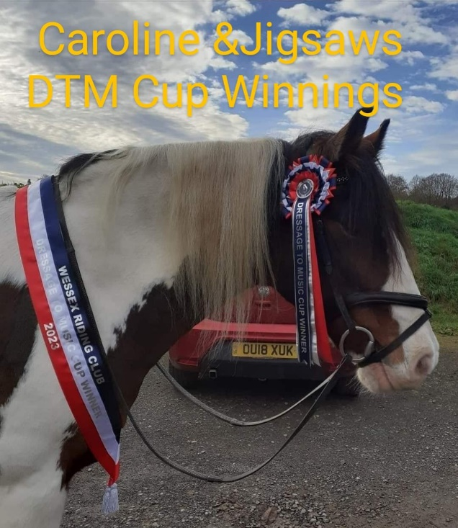
As we look forward to next year, we have some events and training already booked. Thinking of chilly January, we have two non-ridden undercover training sessions planned with hot drinks and an additional option for a session on the horse simulator afterwards.

The first is on the 14th of January 11- 1pm at Hilltop Equestrian in Pitton with Tammy Weal. This will be an interactive in hand demo looking at developing and exercising the horse including lunging and long reining. Simulator sessions can also be booked from 1 30pm.
On 28th January Tammy will be holding another demo for us firstly looking at a prelim test and rider then moving onto stripping back a novice test to help improve our scores with what the judge is looking for. Same timings and option for the simulator session after.
Costs will depend on numbers so please email your interest to me and we can secure these opportunities asap. Send the date/s you are interested in to justemmaml@gmail.com
Riding wise our monthly Virtual dressage also starts in January and your PRS hours are always accumulating for members.
I know 2023 has been a tough year for many and we look forward with hope for brighter times and also brighter weather for 2024! Thanks Emma
Pleasure Riding Scheme
Despite increasing costs of everything we are keeping PRS membership the same. We have decided to keep the joining fee to PRS as an additional £12 per year.
How it works for anyone new to the PR: Each member logs their riding hours however they like to do it - spreadsheet, app or handwritten log whichever you prefer. Once you have ridden enough hours to attain your next rosette you let me know and I get it out to you by hand or post.
The rosettes start at 50 hrs and go all the way up to 2000 with the initial rosettes going up in increments of 50 moving onto 100 hrs after 300. All your hours continue on from year to year adding to your running total. Hours can be accrued by doing most riding activities so hacking, schooling, pleasure rides all count just not for lessons or competitions. They can count on any horse so if you ride more than one it all counts.
We also have an optional exclusive What's app group where we post pictures of our horses with their rosettes or of nice hacks or things that may be of interest to others.
In 2023 we have just over 20 members in the scheme and I have handed over 37 well deserved rosettes.
There have been some PRS members who have experienced personal health issues and/or issues with horses meaning a lack of ability to add to their hours. I would like to wish you all best wishes for good recoveries and best wishes for riding into 2024.
For those members that have been able to ride we have several riders that are riding onto higher hours rosettes and have already achieved many.

To date we have-
Richard and Archie on 1700hrs
Nancy and Ed on 1600hrs
Caroline and Jig on 800hrs
Penni and her boys on 800 hrs
Pam and Monty on 600 hrs
Sally and Molly on 500hrs
Helen and Silver on 500 hrs
Yola and Lady on 400 hrs
Catherine and the boys on 300 hrs
And Robert and his boys on 300 hrs.

Also to congratulate are those members gaining their first rosettes including Imogen and Claude, Sam and Ronnie, Mary and Stewart, Emma and Squishy and Rose and Casper.
Mary and Emma have been doing plenty of riding and have already achieved just over 200 riding hours!! They are amongst a few others having done similar hours but on her way to 300 hrs this year already I must congratulate our WRC Pleasure rider of the year... Rose Clarke with her wonderful boy Casper!
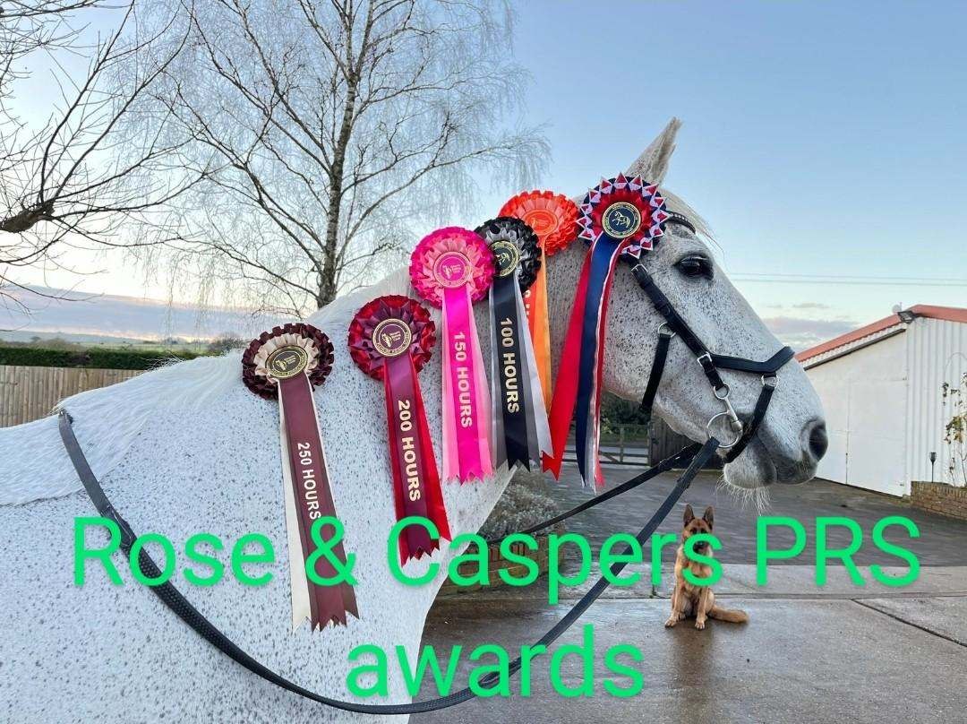
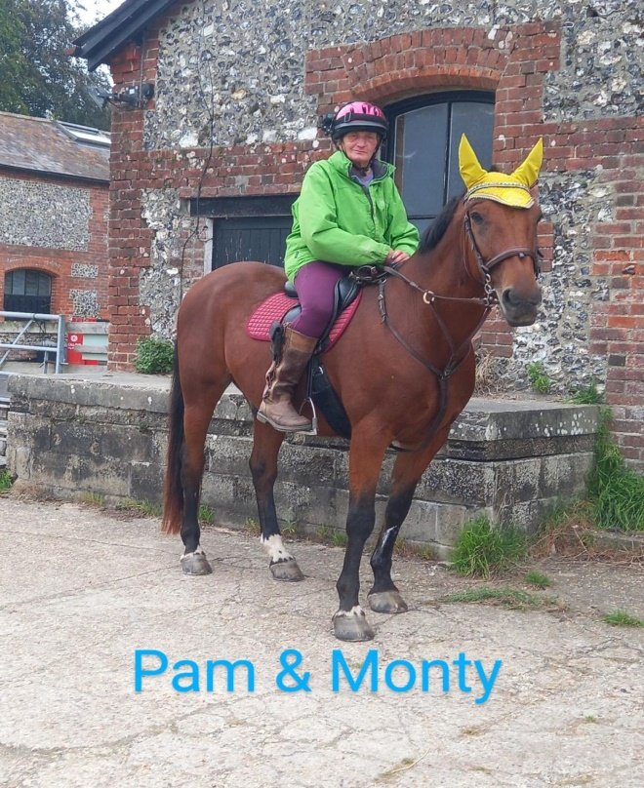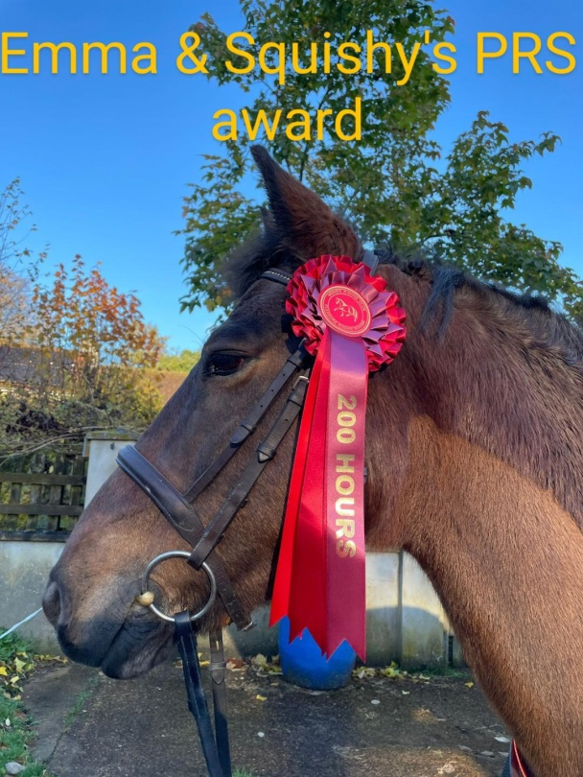
Clothing
Please do take a look at our new WRC Clothing, available to purchase for humans and horses online through JS Teamwear https://www.jsteamwear.co.uk/shop/british-riding-clubs-pony-clubs/wrc/

Facebook
Please check out our Wessex Riding Club Facebook account. We do try and keep as many people as possible engaged via our Facebook page, so please keep visiting and engaging in our content.
There are photos from our past training events and competitions as well as information and dates on events coming up.

BCR Changes
As of 1st January 2024, the BETA 2009 tagged Body Protectors will no longer be legal for British Eventing, British Riding Club and Pony Club events. This means that the BETA 2018 level 3 standard will be required when training and competing with fixed fences.
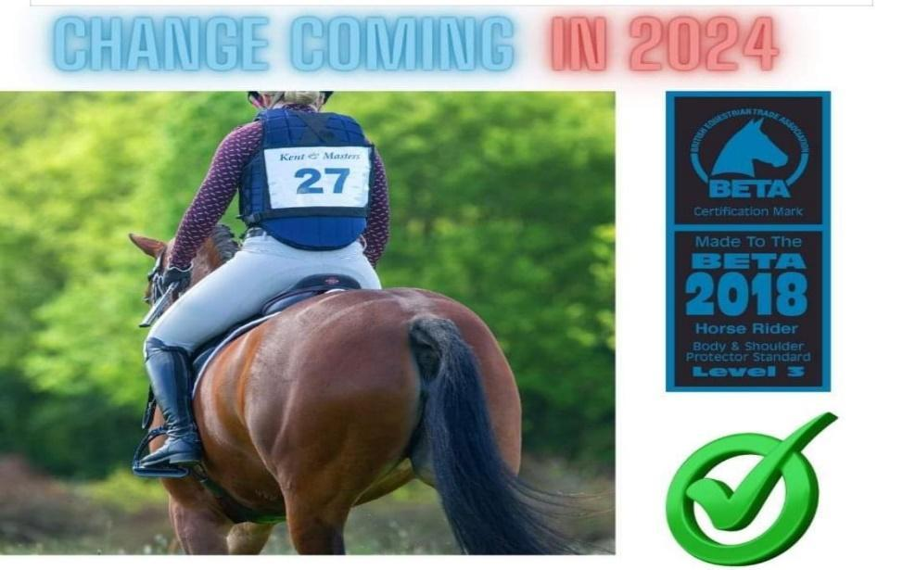

Please follow the link below, where you can download the BRC Handbook for further information on all BCR matters.
https://www.bhs.org.uk/british-riding-clubs/brc-downloads/brc-handbook/
.
If anyone has anything they may like to put forward as a potential social gathering or event that you may be interested in helping to arrange, then please get in touch.

Email Jody: jodystoker@yahoo.com

Thank you all for your continued support to WRC and we hope to see you all again in 2024. Please remember without all our members we wouldn’t be able to do what we do.

Thanks for reading and have a fabulous Christmas and New Year from Jody, Emma and all the WRC Committee.

Please find attached Andrews Champs blog.

