Dates for your diary:

Dressage Virtual 1st – 31st Oct
Dressage Actual 31st Oct – it’s a Halloween special. Fancy dress optional. Judges awards XX

AGM : November 16th 2021 at RDA
Food order to be completed and returned to Hazel by 10th Nov 2021
October Newsletter 2012
Wessex Riding Club
NO

Welcome to the WRC newsletter

HI everyone

First and foremost, an apology to everyone, I have been absent from newsletter duties due to some serious health issues at home. I have to admit that the last few months have been tough as my partner was admitted with kidney failure into SDH and the Portsmouth QA for treatment. I wondered what and where we would all end up? I have had the most amazing support and much has come from my horse ‘community’. I don’t want to dwell on my troubles but I want to thank everyone for their kind wishes and support.

I had booked a session for Monty with Elaine, the horse healer, prior to our meltdown, at what turned out to be a critical week of family trauma. Whatever you feel about this aspect of treatment/ culture and I reserve the right to be skeptical too, but, Monty rose to the occasion and seemed to take on board the challenges I was facing. Elaine promptly explained to him that he was needed: I had a calm, loving brother, rather than 700kilos of muscle wanting attention. He nuzzled, nudged, licked and chewed and made me feel ok. Looking back on those early days of this nightmare he made a difference, he showed he felt that his input was needed (it was!) and he reminded me constantly that carrots are vital. My horse has been my salvation in a time of need and I sincerely hope you get the same the vibes if ever you need them xx

My greatest thanks and appreciation go to the team who basically ‘got on with the job’ without me. The WRC committee team have been amazing! The events and the credits have been rolling in on Facebook and I know activity has been wonderful. I even managed to get a day in at a camp which I can highly recommend. The last one

of the year is booked for 17th October which is fully booked but Lorna is trying to arrange training for November so keep an eye out for an email from Lorna if you want to get a chance to spend a very enjoyable, challenging day.

My lucky break came in September, I was very lucky to get a chance for a day at camp so for those who haven’t done one this Is how Monty and I fared.

I had a morning arrival session with my ‘inner core’ doing some very interesting techniques from a Pilates teacher called Lisa – who is also a rider. That makes a difference! I, and the other victims, got to re-acquaint ourselves with our seat-bones and understand their importance in our riding position and posture.

We then moved onto a session in the outside school over Poles with Sarah Michell Shepherd – so many poles and so many turns! I was teamed up with Caroline on Jig, two coloured horses – what could possibly go wrong?

I started this session with some serious concerns and ended up laughing all the way around, in canter. Who would have thought it? I loved it and Monty was a very happy chap. My colleague and I felt we accomplished things that took us both by surprise – the ‘Can Do’ culture won hands down, rather than ‘Maybe another time’!

It was then time for a break and a breather. The weather was wonderful and we sat in bright warm sunshine with a cold drink and tasty snack, life seemed very satisfying. Our attention was then turned to the indoor school where Heather put us through our paces. Caroline took a breather and passed over to Claire who rode Jig whilst Heather took us through some very familiar parts of well-rehearsed Prelim tests, but stretching to the next stage of the movement which would be what one could expect within Novice. A challenge in itself, but, great homework to practice and build confidence

Tired and happy we all went our separate ways having had an enjoyable and rewarding day out!

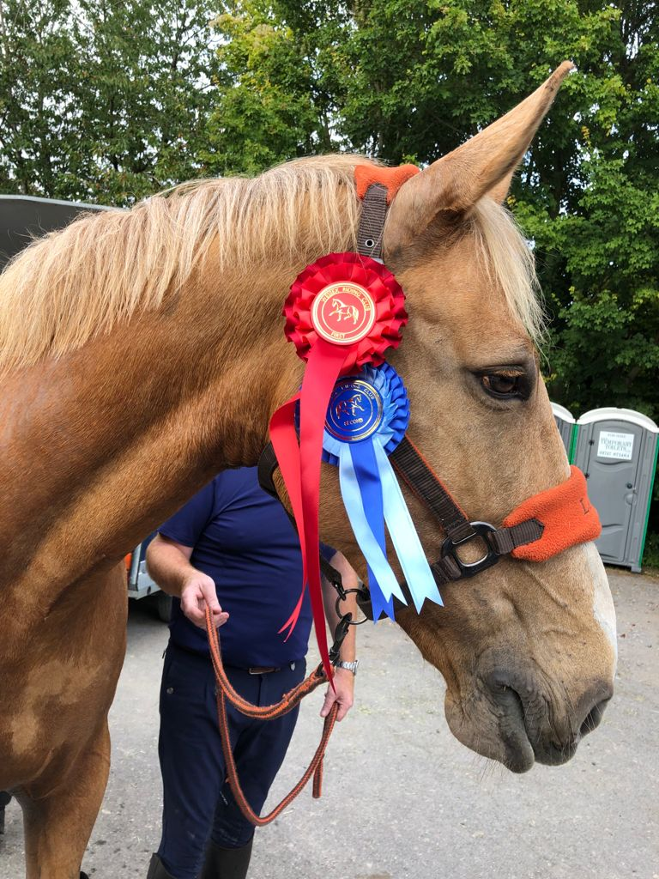

Noodles – Ride Coach Ride successes

I received an email from one of our members Nancy, who wanted to share news with us all and make everyone aware of something that she had witnessed at a recent show.

Nancy had been at an event when a disruption occurred and one of the competitors found, on returning to her lorry, that all her tack and some personal possessions had been stolen. It appears that a team of well - organized thieves had wandered around the parked lorries helping them-selves to what was parked and left unattended, as is often the case at horse events. We all need to be vigilant, but I know in the heat of getting ready, tacking up, washing down or just the frenzy of being ready we take for granted that the lorry will look after itself. In some cases, as seen in local newspapers, the lorry goes missing too!

The email came as a warning. If it moves lock it up– if you aren’t there someone may help themselves to what is yours and I can confirm to you from other tales I have heard that some visitors to events go with that very aim in mind. A sad, but true, fact. Thankyou Nancy, for sharing your concerns with us.

Moving onto the Dressage competitions for October and November, the dates are in the diary and on the web site. Special event for October to celebrate Halloween see web! Emma Palmer has been very busy writing some tests especially for us, so I am attaching an update from her.

Hi !
I would like to tell you a little bit about the dressage tests that I have written.

The first Walk and Trot test has been ridden and judged already and I hope that it will be ridden and judged many more times. Of course, there are riding club walk and trot tests and Intro A, B and C but I wanted to add to the limited choice of walk and trot tests available to us. There is also more than enough in this test to really challenge both horse and rider with a variety of movements to use in training and to demonstrate If you would like to try an alternative test that does not include a canter then do give this one a go!

There are elements to practice which do appear in prelim tests such as give and retake the reins and transitions on a circle as well as movements introduced at Intro level such as Trot walk Trot and allowing the horse to stretch in trot on a circle. Once your navigation is sorted, I hope you enjoy it and it should flow nicely!
Following on from this I have written several Walk, trot and canter tests the first of which is out for October. This first test starts with trot work that covers most of the arena in half circles and diagonals, so you ride a good trot all around the school before any canter work begins. Canter is then picked up in the corner and straight into a circle so if the transition becomes delayed or lead is incorrect there are opportunities to correct it by being on the circle. The canter is only this circle and the long side then back to trot and a change of rein along the short diagonal to give time to prepare for the second canter, again with the transition in the corner and straight into the circle encouraging the correct lead.

The judge will be busy giving you lots of marks as the sections are broken into small segments -so no need to worry about marks being lost for one not so good bit as there will be many other sections to gain marks for all your very good bits! So do give this one a go if you want to ride a test that includes canter or perhaps use it to add structure to your schooling sessions even if you don't want to or can't compete!

With that in mind Emma then followed up with a report on the Ride Coach Ride (RCR)session at RDA on Sunday 26th September so I thought for those of you who are tempted to attend the next one here is a flavour of what goes on….

Here goes...

‘This month the dressage competition took place with the Ride Coach Ride format at the RDA on 26th September.

The outdoor school was available for warm up with Nancy kindly keeping everything timely as the competitors came down to the indoor arena to ride their tests. Julia Corey was our judge and coach doing an amazing job as the tests ridden ranged from Intro to Elementary. Each test was ridden and judged then coaching took place within the time allocated and the chosen test re ridden and scored again. The coaching was excellent and everyone improved taking home much more than their test sheets and rosettes!
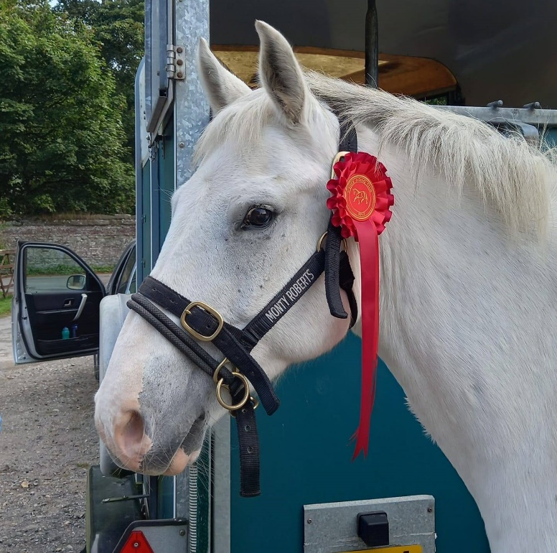
Silver – a well earnt rest!

With much thanks to Julia Corey for all her hard work and expertise and the RDA team ensuring the venue was top class.

Much appreciation to Ali for all her hours of organization and help, not only on the day but for all her hard work behind the scenes. Big thanks to Hazel (for bossing us all around, someone needs to be organized!!) stewarding, parking, tidying and scoring, and to Nancy for stewarding the collecting arena and to Claire for scribing for Julia and tidying up.

Thank you to all competitors for coming with their lovely horses - it was a joy to see so many improving in such a short space of time. Looking forward to seeing everyone again soon and best of luck to all October competitors! ‘
Emma (caller, poo collector and score assistant!)

🙂🐎😀

The Dressage to Music evening was a huge success and well attended. This workshop has been a great hit and I was really pleased to see so many turn out. Big thanks to those who organized and those who took part. I am hoping we can repeat this as I for one missed it. Photos attached show what a great night it was.

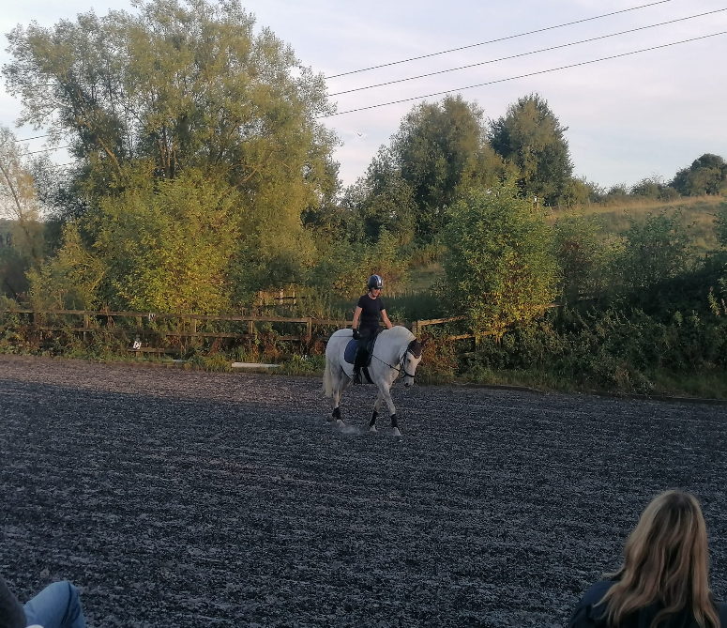
Maggie and Robert DTM display

An important plea to all members

We need to hear from you and what activities you want us to take forward. Sam Painter is our Area 17 rep and very keen to get teams together to take part in Arena Eventing and cross country so we have a broad choice for everyone to be able to dip their toes in the water – so to speak!

The AGM is a wonderful opportunity for members to meet each other and talk to the committee members about their ideas and what you would like to do next year. I truly believe the club will go from strength to strength but we need your input. We are hoping that more events, training and we want to resume the Talk and Chat evenings we used to have Pre Lockdown. So fingers crossed we go forwarded towards 2022 with all the lights on and lorries firmly locked!
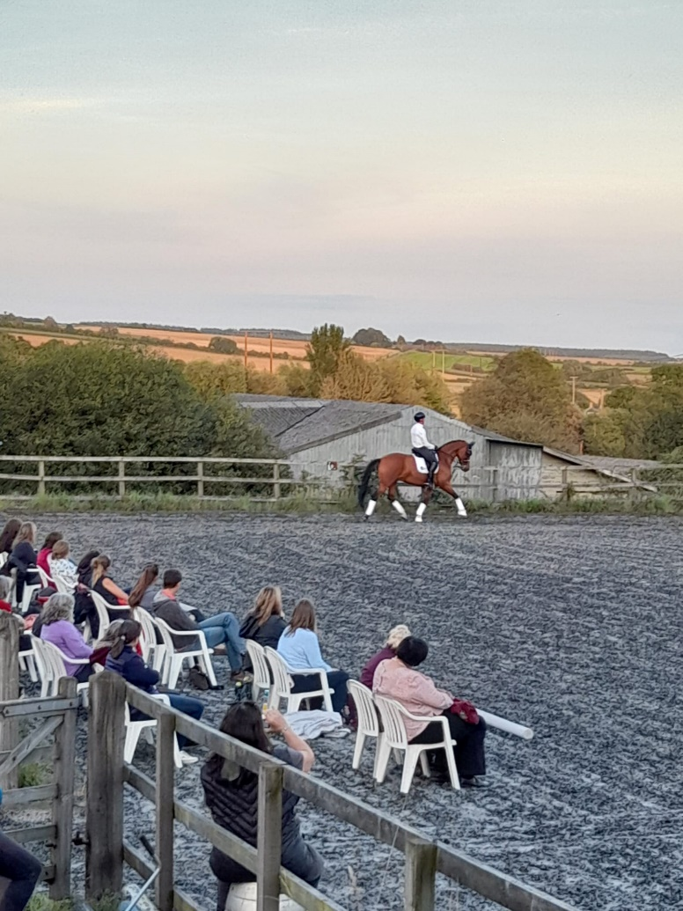

Dressage to Music Demo – beats the beach anytime!

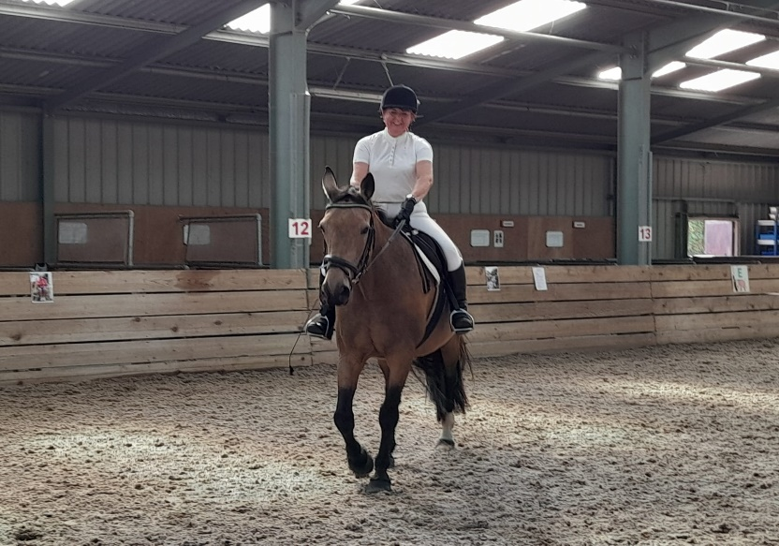

Truly Scrumptious – Shelley at RCR

THE Annual General Meeting will be held at RDA Wilton for the Club on 16th November 2021. Attached to this newsletter is a food order flyer giving you details of the food on offer so if you can make it, please ensure you place your order so we can ensure we have food especially for you. The cost to members is free, and we need to know about numbers as soon as possible.

The plan is to arrive and settle for 6.30pm, starting the meeting for 7pm, then food arrive at 8.00pm.
The meeting will be an opportunity for members to ask questions and put forward suggestions for events that they would like to see take place. Obviously, we have been severely restricted over the
last 20 months due to Covid, but let’s see what winter brings? We will review the year briefly and everyone needs a pat on the back but there may be a few awards dished out too.

A few changes to the committee membership will be proposed and hopefully seconded and then it will be down to the food and chat.

We will be running a raffle for some scrumptious horsey and other influential treats so bring your money – tickets available on the night. Finally NEW 2022 membership forms for renewal and new members will be available so we start the year off with a big bang. We were all thrilled to see the membership go over 60 this year despite the restrictions, so let see if we can launch into 2022 with a strong membership. The Membership Fee remains at £25.00 and the start of the year is 1st January 2022. I must also remind people to renew their Pleasure Riding Scheme subs, if in doubt contact Caroline who will be able to confirm when these are due. They, unlike Membership, are on a rolling calendar, anniversary date down to when you first joined. Like membership this scheme has increased this year and we think that it’s a great way of tracking hours in your saddle.

With that all in the melting plot, we look forward to
seeing you on the night or at one of the events in
October or November.

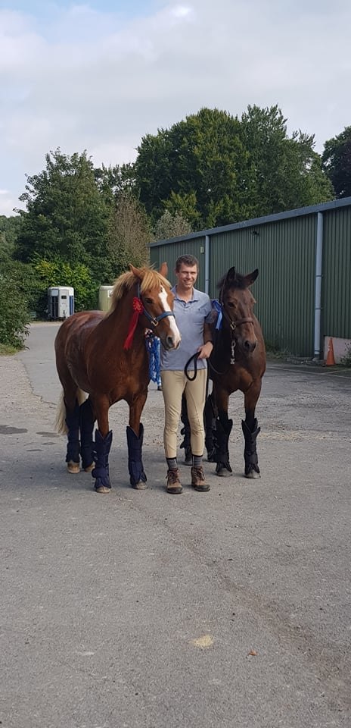
Robert with some friends and awards from our recent R.C.R.

Take care of yourselves

Janet and the committee.

